22.57: a) The total charge: 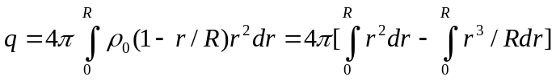

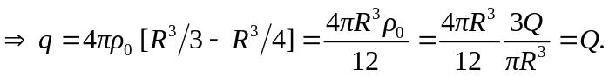

b) 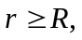 all the charge  is enclosed, and: 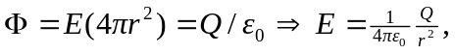 the same as a point charge.

c) 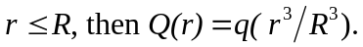
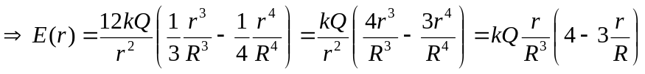

d)
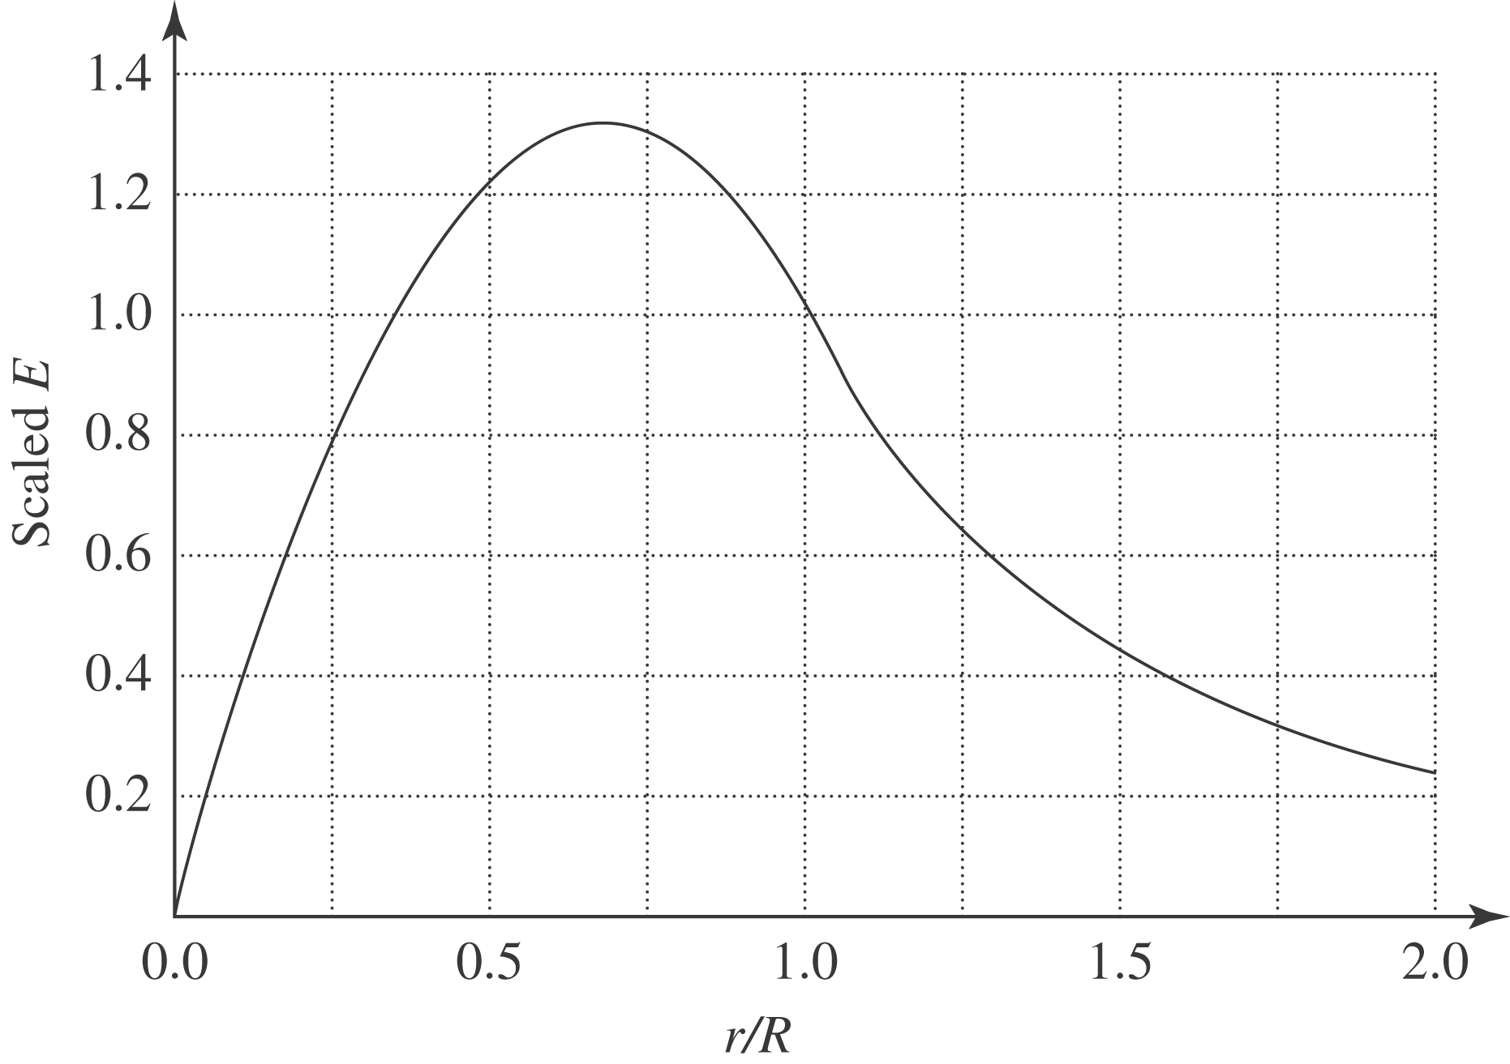

e)

